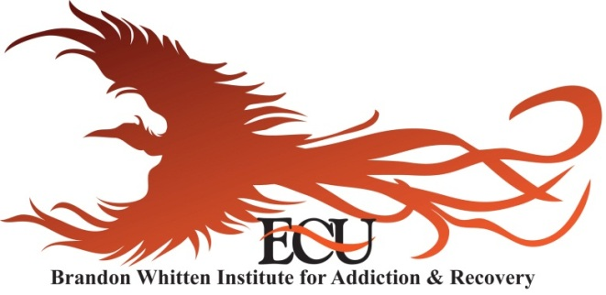

Motivational Interviewing: Opening Doors in the Walls of Denial
Provided by Joel Rutledge, LPC, LADC

Friday November 15, 2013
8:30 a.m. – 11:30 a.m.

Estep Auditorium
In ECU’s University Center

This workshop will focus on strategies for choosing appropriate interventions for different clients in different situations. Rutledge will discuss opening doors, as opposed to breaking down walls of denial.
Community Registration: $35
For community early bird online discount of $10 use code: FALL
(Only $15 for ECU Employees or Students with a valid ECU ID#)

Continuing Education Units (3 hours) have been requested for LPC, LMFT, LCSW, CADC, LADC, Case Managers & Peer Recovery Support Specialists.

You may register online at www.ecok.edu/ce by clicking on ‘Enroll Now’ and selecting this course from the list of courses. Registration is also available in person or by telephone at the ECU Center for Continuing Education & Community Services in Fentem Hall, Room 114, Lindsey Tilley 580-559-5465. (ECU employees and students must register in person or by phone with CE Services).

***If special accommodations are needed, please contact BWI.***
Sponsored by East Central University & Brandon Whitten Institute for Addiction & Recovery. Please call BWI at (580) 559-5720 or (580) 559-5815 for more information.

